Cruise Control

System of a Vehicle

# Using PID Controller



JEEVA S-2023PECEC525

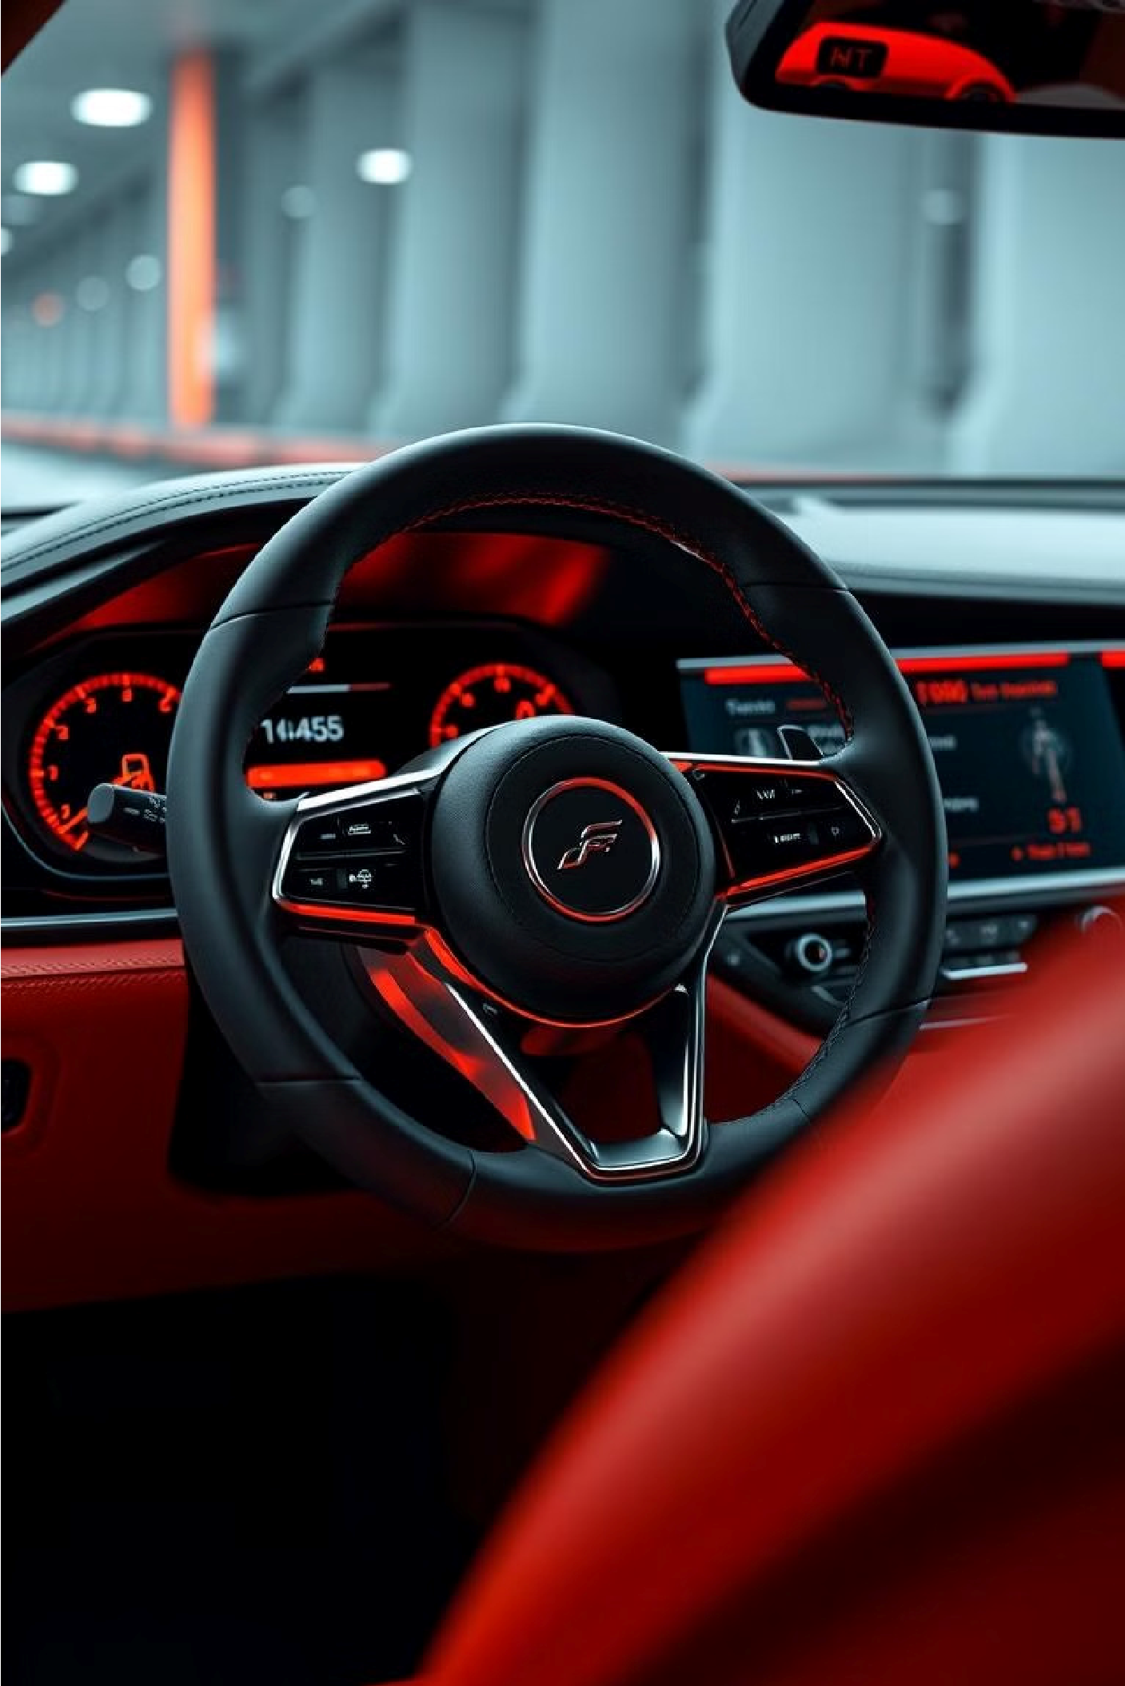

Abstract for Cruise

Control System of a

Vehicle

This presentation provides an in-depth overview of the cruise control system

in modern vehicles. It explores the key components, working principles, and

benefits of this advanced technology that enhances driving comfort and

efficiency.



Block diagram of Cruise

Control System

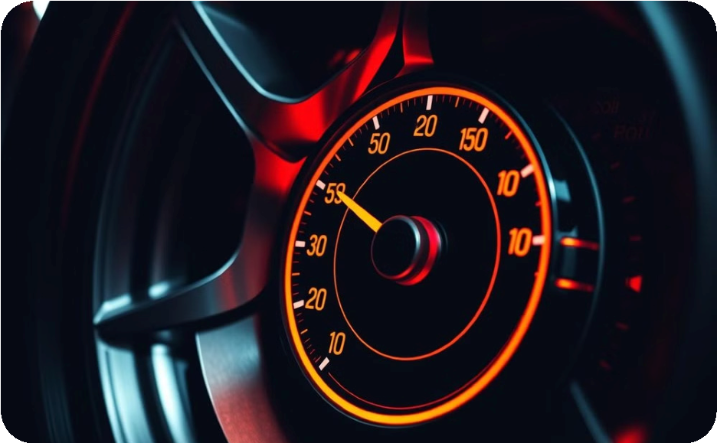

1

.Speed Sensor

Measures vehicle speed and sends

data to the control unit.



2

.Control Unit

Processes speed data and adjusts

throttle.

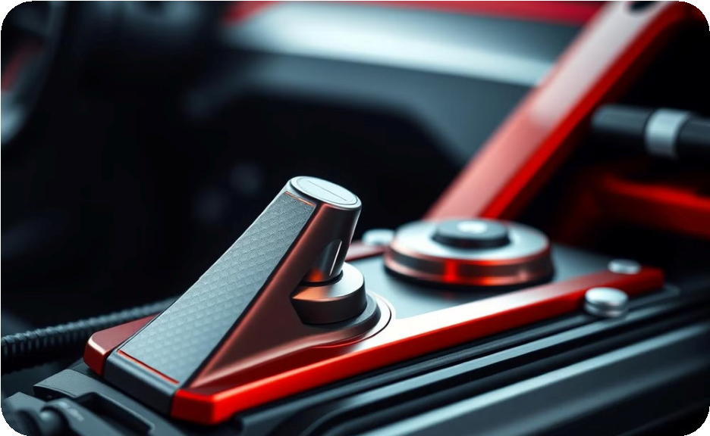

3

.Actuator

Adjusts throttle based on control unit

commands.

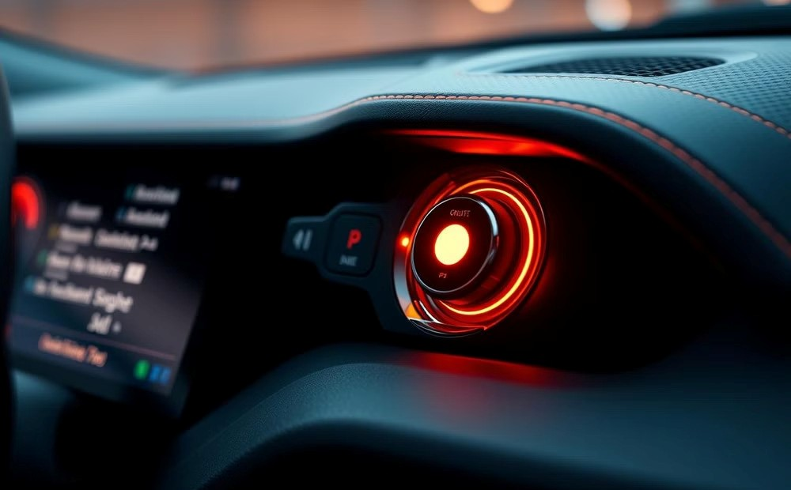

4

.User Interface

Allows driver to set, adjust, and

disengage cruise control.

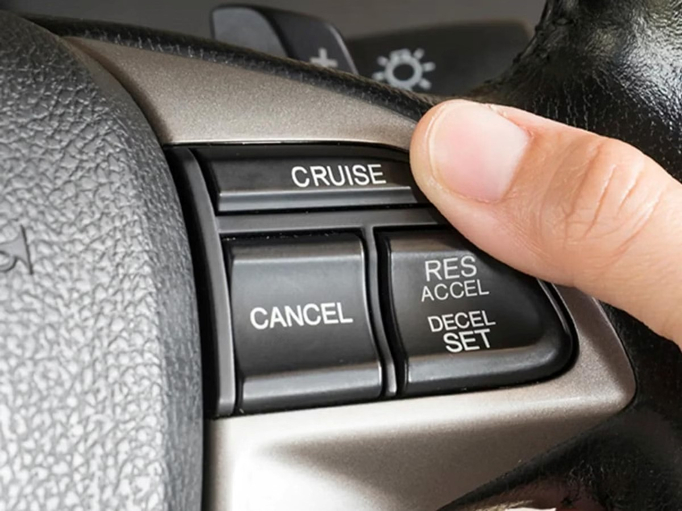

What is Cruise control?

Definition: Cruise control is an automated system that

maintains a constant speed set by the driver.

1.

The cruise control system is a valuable feature in modern

vehicles, allowing drivers to maintain a constant speed

without the need to continuously press the accelerator pedal.

2.

The system takes over the throttle of the car to maintain a

steady speed as set by the driver.

3.

It is system that allows you to set your car to a specific

speed, letting you take your foot off the accelerator pedal.

4.

Cruise control - automatically controls the speed of a motor

vehicle.

5.

purpose: Enhances driver comfort during long-distance

driving and improves fuel efficiency.

6.

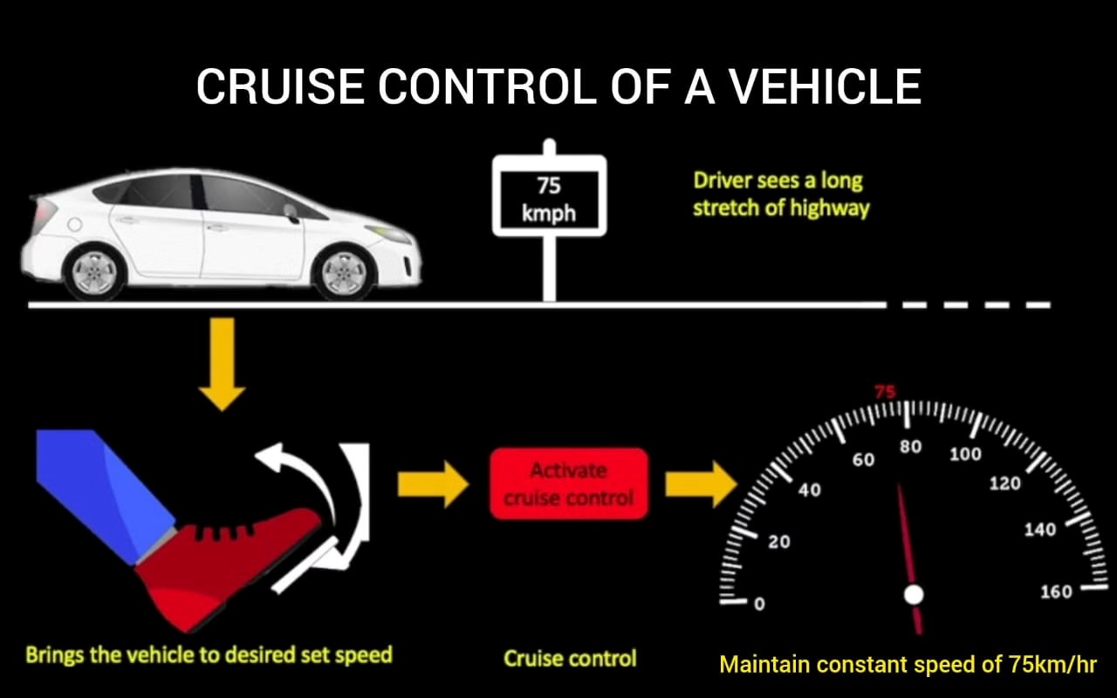

Adaptive Cruise Control

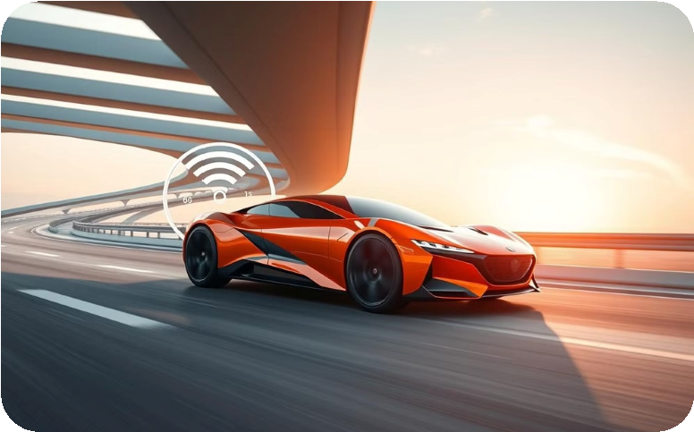

Radar, cameras, and

sensors

Monitor the surrounding traffic

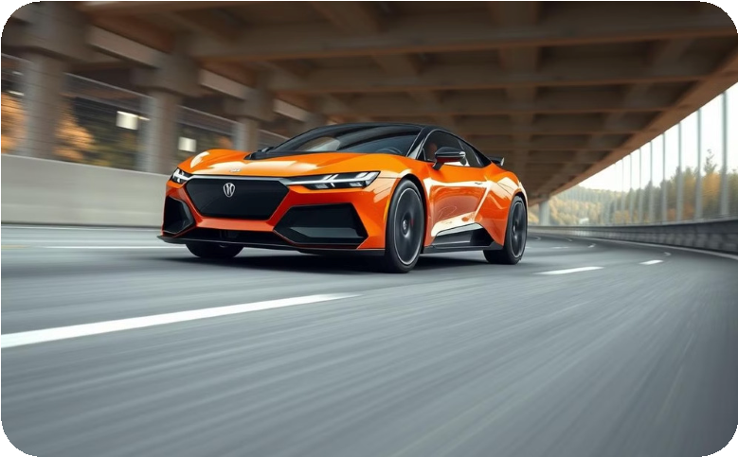

Automatic acceleration

and braking

Adapt to changing road

conditions

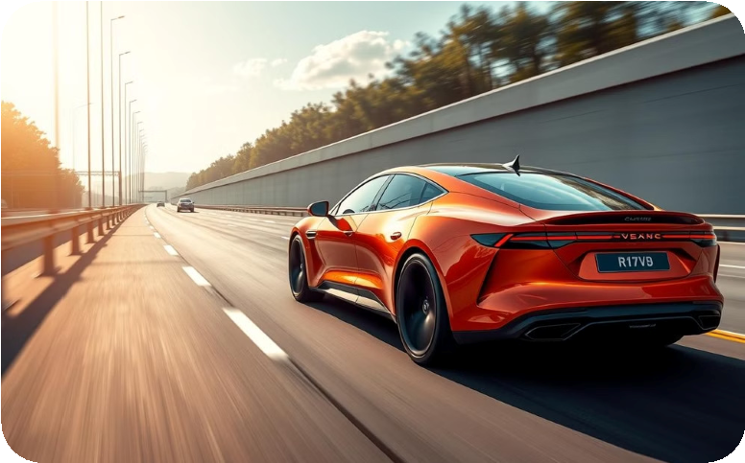

Safe following distance

Maintain a constant speed and

following distance



Reduced driver fatigue

Enhanced safety and

convenience

Adaptive cruise control (ACC) is an advanced cruise control system that automatically adjusts the vehicle's speed to maintain a safe

following distance from the car ahead. This intelligent technology helps reduce driver fatigue and improves fuel efficiency by

automatically maintaining a constant speed and following distance, even in stop-and-go traffic. It represents a significant step towards

autonomous driving, enhancing safety and convenience for modern vehicles.



Application of Cruise Control System

Maintaining Constant Speed

Cruise control allows drivers to

maintain a consistent speed on

highways, reducing the need for

constant acceleration and braking.

Improved Fuel Economy

By keeping the vehicle at a steady

speed, cruise control can help

improve fuel efficiency and reduce

fuel consumption.

Reduced Fatigue

Cruise control can help alleviate

driver fatigue on long drives by

automatically adjusting the vehicle's

speed, allowing the driver to focus

on the road ahead.

Enhanced Safety

Cruise control can help drivers maintain legal speed limits,

reducing the risk of speeding and associated safety

hazards.

Adaptive Capabilities

Advanced cruise control systems, such as Adaptive Cruise

Control (ACC), can automatically adjust the vehicle's speed

to maintain a safe following distance from the car in front.

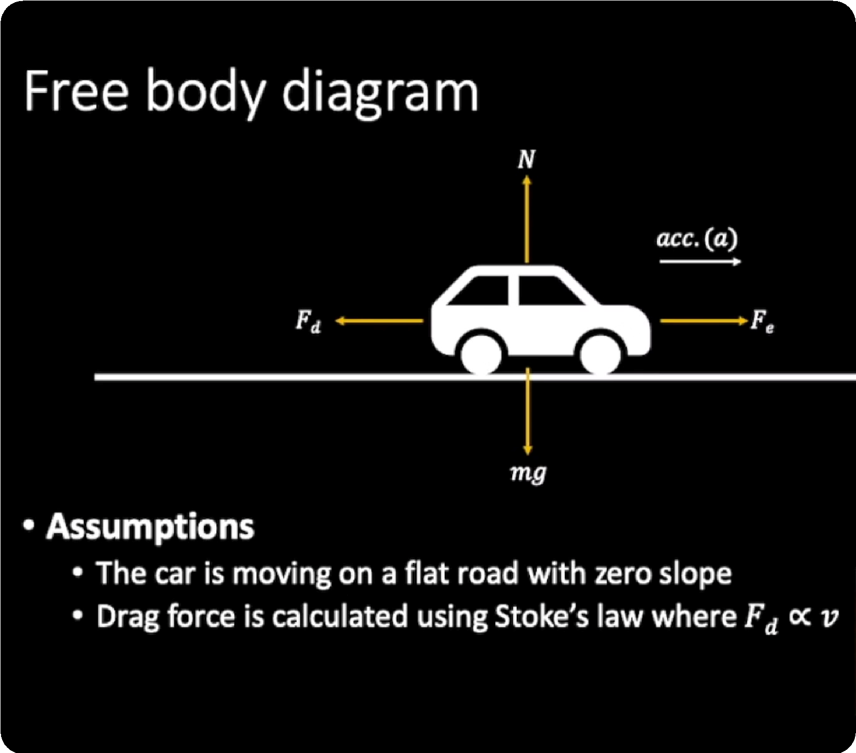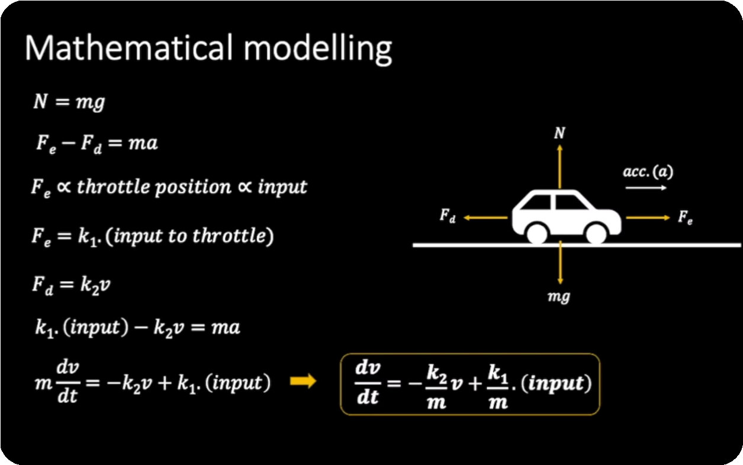

SIMULATION

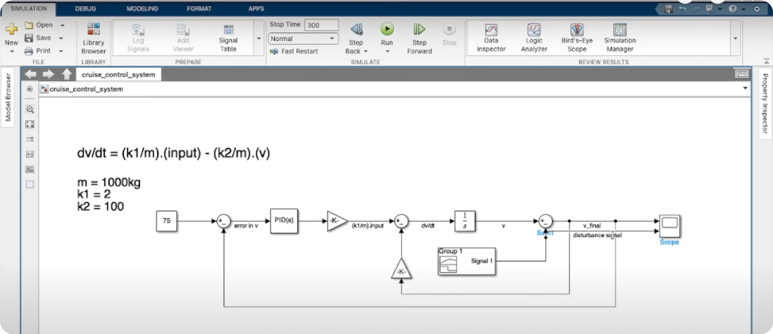

OUTPUT

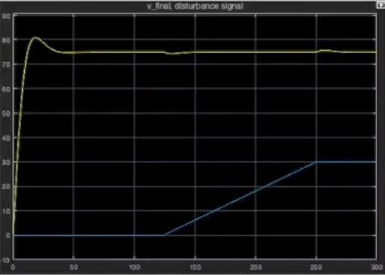

The Future of Cruise Control Technology

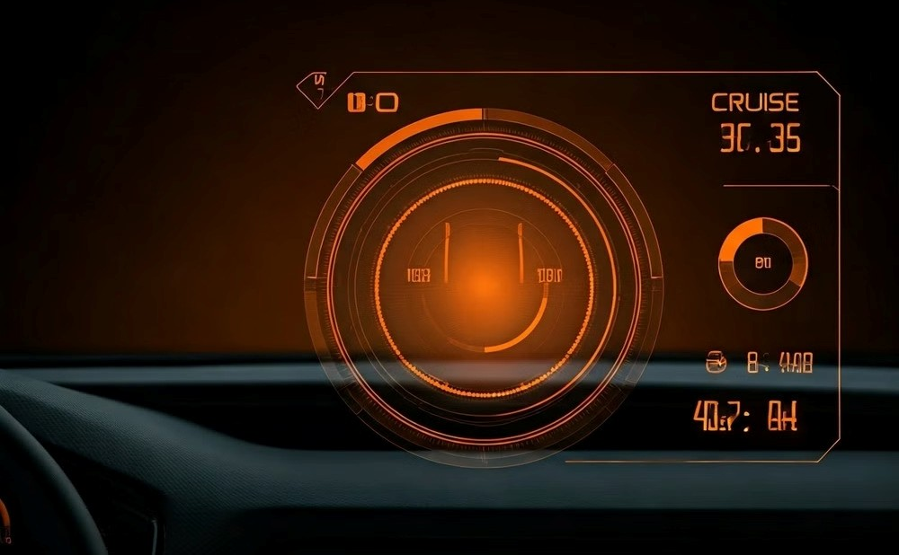

Advanced User Interface

Cruise control systems will become more intuitive and user-

friendly through advanced interfaces, such as heads-up displays.

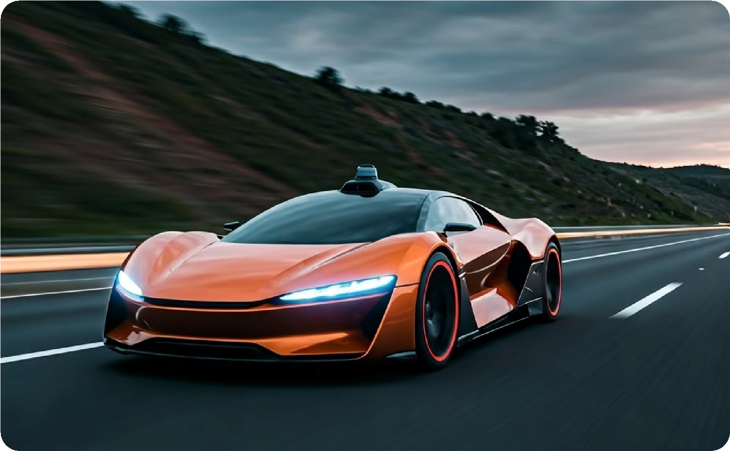

Integration with Autonomous Driving

Cruise control will play a crucial role in the development of

autonomous driving technologies.



conclusion

Summary: Cruise control is an essential feature

in modern vehicles, improving comfort, safety,

and efficiency.

Looking Ahead: As technology advances, cruise

control systems will continue to evolve toward

fully autonomous driving.



Key References for Cruise Control Systems

**SAE J1939:**

This standard defines the communication protocols and message formats for electronic control systems in vehicles,

including cruise control.

**ISO 15622:**

This international standard specifies the performance requirements and test procedures for adaptive cruise control

systems in road vehicles.

**NHTSA Regulations:**

The National Highway Traffic Safety Administration (NHTSA) in the United States has issued regulations

governing the design and safety of cruise control systems.

**OEM Technical Documents:**

Vehicle manufacturers provide detailed technical manuals and service information for the cruise

control systems in their specific models.

**Research Papers:**

Academic and industry publications explore the latest advancements in cruise control technology, such as

sensor integration and autonomous driving applications.